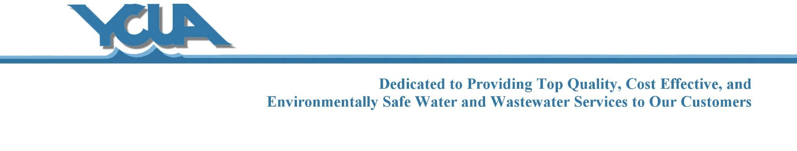
Job Description: Custodian/Groundskeeper

Pay Class: A-8
FLSA Status: non-exempt
Updated: 5/2015

POSITION SUMMARY: Perform maintenance tasks with appropriate equipment; maintain and clean equipment; clean inside and outside of facilities; and perform routine outdoor grounds keeping functions.

Essential Functions:
- Mow facility grounds and off-site stations.
- Maintain landscape: water, cut and trim shrubs, trees, and brush; weed facility grounds and off-site stations.
- Perform custodial tasks including, but not limited to: cleaning/sanitizing restrooms; clean, mop, wash, buff, and vacuum floors; clean and polish fixtures; clean windows; dust furniture.
- Maintain outside areas including sweeping and snow/ice removal with shovels and plow trucks.
- Use skid steer to load dumpsters with land fill material.
- Drive trash to dump.
- Collect and remove recycling materials.
- Pickup and deliver materials and equipment inside and outside YCUA property.
- Paint and perform minor maintenance of buildings and equipment.
- Maintain necessary logs, records and reports as required.
- Must fulfill the departmental overtime requirements.
- Perform other related duties as required.

Knowledge, Skills and Abilities:
- H.S. Diploma or GED required.
- Valid Michigan Driver’s License required.
- Passing score on the Custodian/Groundskeeper entry test required.
- CDL B license must be obtained within 90 days of employment.
- Ability to operate Gondola truck and loading equipment.
- Landscape or building maintenance trades experience preferred.
- Ability to follow directives faithfully and work without close supervision.
- Ability to clearly communicate procedures, problems, and policies with fellow employees and the public in a tactful and courteous manner.
- Ability to perform manual labor; ability to work in adverse environmental, extreme weather and field conditions.
- Working knowledge of operating computers and software, including Microsoft Office platform.

Physical Demands:
Physical Demands Lift/Carry
- Stand- Frequently - Less than 10 lbs- Frequently
- Walk- Frequently - 10 - 29 lbs- Frequently
- Sit- Occasionally - 30 - 59 lbs- Occasionally
- Handling / Fingering- Constantly - 60 - 100 lbs- Occasionally
- Reach- Frequently Push/Pull
- Climb- Frequently - Less than 10 lbs- Frequently
- Crawl- Rarely - 10 - 29 lbs- Frequently
- Squat or Kneel- Occasionally - 30 - 59 lbs- Frequently
- Bend- Frequently - 60 - 100 lbs- Occasionally

Reports to: Maintenance Supervisor (plant site) & Water System Supervisor (service center site)

